#3528 LED Light Strips

The LED Light Strips are designed to operate on 12 volts DC, making them perfect for use on any model that uses a 3-cell 11.1 volt Li-Po battery. They will operate on as little as 9.5 - 10 volts, so they should stay illuminated as long as your battery has enough voltage to run your motor and servos. There are several ways you can tap into your battery’s power, I’ll give you a couple of suggestions that I have found work well.
The easiest and simplest way is to add a pair of wires to the large red and black input power wires on your ESC, the ones that connect the ESC to the battery. There’s usually a plug of some type there, maybe a Deans-type plug or one of the newer yellow X60 connectors. Whatever type of connector you have, remove the heat shrink where the (+/red) and (-/black) wires from the ESC are soldered to the connector, and add a small 20-24 gauge wire to each. (Don’t forget to slide a new piece of heat shrink onto each of the ESC’s wires before you add the new wires, so that once you’re finished adding wires you can cover the joints again with heat shrink.) Now that you have a pair of smaller gauge wires coming from the ESC’s power wires, you can connect them directly to your LED’s, using the solder pads closest to where your ESC is located. Be sure to observe correct polarity when connecting to the LEDs. If you think you might occasionally want to fly without using your lights, you can add a second smaller connector of some kind to these wires, like a mini-Deans or a JST connector, so you can disconnect the LEDs separately, without unplugging the ESC from the battery. We sell both the JST and mini-Deans connectors if you need them.
Another method is to use the balance tap on your Li-Po battery for power to the LEDs. Just solder a couple of small gauge wires, about 20-24 gauge, to the solder pads closest to where your battery is located, and solder a male balance-tap connector to the other end. If your plane uses a 3-cell battery, the two outside wires on the balance tap will provide the full ~12 volts you need. If your battery is bigger than a 3-cell, you’ll need to use the negative wire (should be black) on one side/end of the balance tap, and the 4th wire from it, which should be the positive wire of the 3rd cell in the pack. Check the voltage across them to be sure you have the correct wires, they should measure somewhere around 12 volts. We also sell the male balance tap connectors if you chose to use this method. I do not recommend that you connect more than a couple of meters to a balance tap, because most balance tap wires are too small to be able to handle the current used by more than 2 strips.

(continued on back)

These LED strips can be lengthened or shortened as needed. To lengthen, simply add more LEDs by soldering them together end-to-end, observing the correct polarity, of course. There are + and - markings printed on the strips. To shorten, cut at the indicated marks, after every 3rd LED. Cut between the pairs of solder pads, so you’ll have a place to make connections on each end of the strip once you cut it.

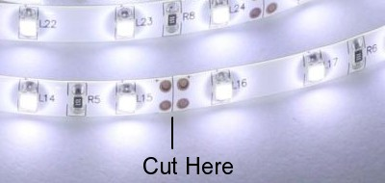
If you lengthen the strips, consider the total current drain when you add wires to connect them, and also as you choose the battery you’re going to use to power them, as they are rated at 400mA per meter. Just make sure the connection wires and source battery are big enough to handle the load. If you’re using these LEDs on a car, boat, motorcycle, or other 12 volt vehicle, you can connect them directly to the vehicle’s battery or wiring system, I recommend that you install an in-line fuse holder with the proper size fuse to protect against an accidental short circuit. Choose a fuse that’s about twice the total current draw of all the LEDs you install, i.e., for 2 meters of LEDs, use a 2 amp fuse (400mA/per meter X 2 = 800mA, or .8 amp) The fuse can be place in-line on either the positive (+) or negative (-) lead, but I’d recommend you put it on the (+) lead.

If you have any questions or problems, don’t hesitate to contact me. ENJOY!
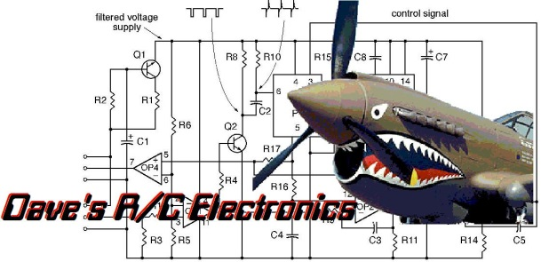
www.davesrce.com
sales@davesrce.com
(423) 544-1657
SCAN HERE

