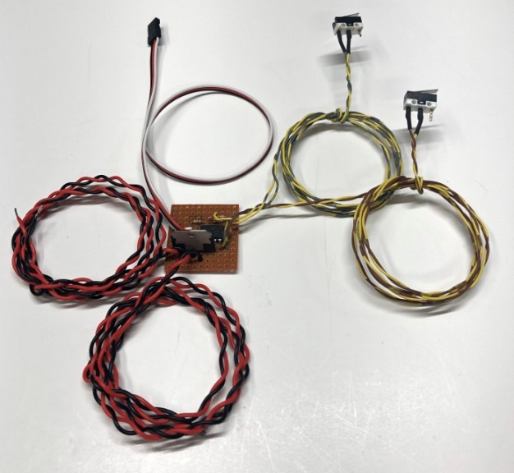
Brushed Motor Controller
The Brushed Motor Controller is designed to provide bi-directional control of any brushed motor that operates on DC current using your RC transmitter, allowing you to control the motor without the need for a separate on/off switch mounted somewhere on the model. New programming includes a “center off” function that will stop the movement of the motor whenever the channel is moved to center. In addition to the main control board, it includes a pair of small micro-switches that can be installed as necessary in the model to cut power to the motor when the mechanism has reached the end of its allowable movement. The 1.5 amp H-bridge used to control the motor features an internal overload circuit that cuts power to the motor if the circuit gets too hot, preventing damage to the parts. It will reset itself once it has cooled so that normal operation can resume.
To install the circuit, simply plug the servo cable marked “To Receiver” into the channel you wish to use. (Make sure that the setting for the channel you are using is set to 100% in both directions, and assign a switch or knob to toggle the channel in your transmitter’s menu. If you want to be able to stop the motor’s movement before the mechanism reaches the limits of the switches, you will need to assign the channel to a 3-position switch, a knob, or a stick. Set the center position of the switch to move the channel to the center (0%), and set the other two positions to move the channel to +100% and -100%. (Consult your transmitter’s manual for specific instructions on programming a mix and/or assigning a switch.) Connect the power from your battery or other source to the cable marked “Voltage In”, making certain to observe the correct polarity of the wires. Connect the (+) positive wire to the red, and the (-) negative to the black wire. Now connect the cable marked “Voltage Out” to your brushed motor’s wires. Polarity of these wires does not matter, since the polarity of the motor’s wiring will be reversed by the circuit.
Before installation in the model, connect the circuit to the receiver, to the motor, and to your power source. Now power up your receiver and transmitter and test the operation of the motor, taking note of which switch cuts the motor off moving in which direction. Since brushed motors can be wired in two ways, it isn’t possible to predict which switch will stop the movement of the motor in which direction, so you’ll have to determine which switch you need to mount in which location for proper operation in your model. Once you know which switch cuts the motor off in which direction, you can permanently install the switches in your model.

If you have any questions or problems, don’t hesitate to contact me. ENJOY!
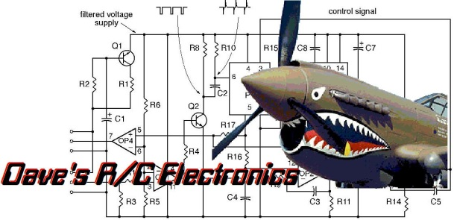
www.davesrce.com
sales@davesrce.com
(423) 544-1657
SCAN HERE

