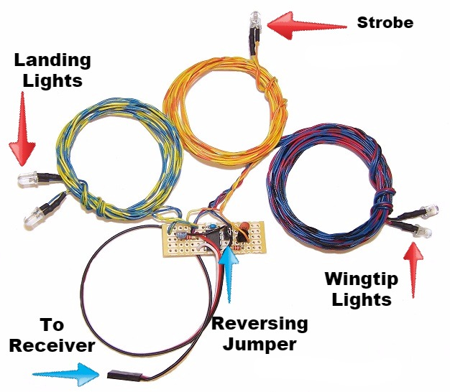
Basic NavLights Set

The Basic Navlights set includes 2 wingtip lights (1 red, 1 green), 2 landing lights (white), and 1 strobe (white, red, or blue). The strobe can be set to 2 different blink patterns, a steady, single-blink or a quick double-blink. The lights are high-brightness LEDs that will last for thousands of hours of continuous operation, and total current draw with all 5 LEDs illuminated is less than 150 milliamps. The wingtip lights and strobe will come on as soon as the receiver is turned on, and the landing lights can be switched on/off from the transmitter. The circuit can be plugged into any channel on your receiver, either by itself or with a servo Y. I suggest you use your receiver’s gear or flap channel, and if necessary, connect it using a wye cable to your retract or flap servos. Any other channel will work, however, so if you prefer, you can install a wye on the throttle servo and use the throttle stick to control the landing lights. Whatever channel you chose, note that if the landing lights come on at the wrong time, like when the flaps or gear are up instead of down, or when the throttle is high instead of low, their action may be reversed without changing your radio’s programming. Simply remove the black plastic jumper located just to the right of the black chip on the circuit board. Refer to the picture above for the reversing jumper’s exact location. If you prefer, you can also program a mix and/or assign a different switch on your transmitter to operate the landing lights. Once the receiver has been turned on, the wingtip lights and the strobe will come on immediately, but the landing lights must be “armed” before they can be switched on/off. To arm them, simply move the switch, knob, or stick that controls them back and forth one complete cycle. They can now be switched on/off at any time.
The position of the switch, knob, or stick that controls the landing lights when the receiver is first turned on (each time) determines the blink mode (single or double) for the strobe. To toggle from one blink mode to the other, turn the receiver off, move the switch, knob, or stick that controls the landing lights to the opposite position, and turn the receiver back on.
If you have difficulty getting the circuit to operate correctly, try increasing the “endpoint” or ATV of the channel you selected for your lights. (Don’t confuse the % of dual rates as endpoint.) For proper operation, end points should be at least 50% in both directions.
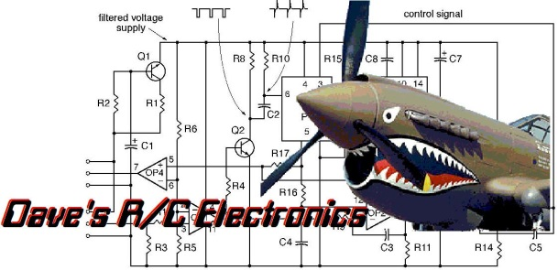
If you have any questions or problems, don’t hesitate to contact me. ENJOY!

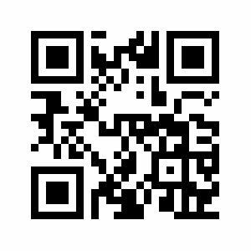
www.davesrce.com
sales@davesrce.com
(423) 544-1657
SCAN HERE

