Servo Y with Trim Pot
The Servo Y with Trim Pot is designed to make the installation and setup of dual servos typically used on flaps and large elevators surfaces quicker and easier. Because of minor differences in the electrical characteristics of servos, sometimes two servos, even though they are the same brand and model, will differ slightly in their center positions. This device will allow you make very small, very fine adjustments to the center position of one servo, and insure that they both move in perfect unison. Installation is simple and straightforward, and this device will work with any brand or type of servo, including standard analog and digital servos, and works with any receiver brand or type, including 2.4Ghz radio systems. Since the circuit affects only the signal coming from your receiver, and does not interrupt the servo’s motor wires, it will not reduce or limit the current going to your servos, and will not affect their performance in any way.

IMPORTANT NOTE: This unit does NOT reverse either servo.

To install the Servo Y with Trim Pot, simply plug the servo cable with the female end into the receiver channel you wish to use. The two remaining servo cables (with male ends) are for connection to your servos. The small trim pot exposed at the top of the circuit board is used to fine tune the center position of one of the servos. Connect the unit to your receiver, and turn your transmitter “On”, then move the trim pot slightly to determine which servo is adjustable. Place the servo arms on both servos in as close to the center position as possible, and use the sub trims on your transmitter to move the “normal” servo to the desired center position. Once you are satisfied with its position, adjust the trim pot to move the arm on the other servo to match the first servo arm exactly. This will ensure that both servos move the same amount when commanded by the transmitter, eliminating roll that might be induced if both servos do not move in sync with each other. Note: Both servos must be connected for the reverser to operate properly.

If you have any questions or problems, don’t hesitate to contact me. ENJOY!
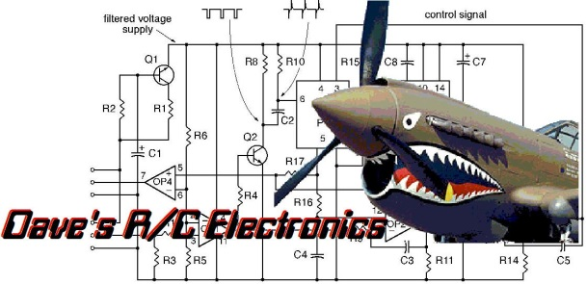
www.davesrce.com
sales@davesrce.com
(423) 544-1657
SCAN HERE

