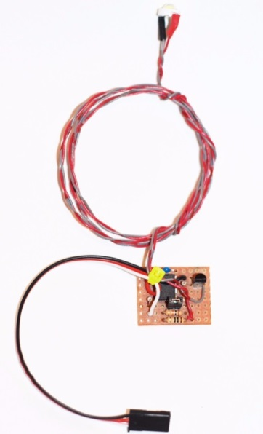
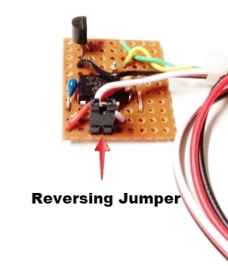
High-Power Strobe (1-Watt)
Plug the servo cable from the circuit board into a spare channel in your receiver, and program a mix to activate the channel using a switch on your transmitter. The strobe will come on/off as the transmitter’s switch is toggled. The LED is a high-power 1 watt emitter, but current draw is minimal due to the strobing function provided by the circuit.
The small, black jumper on the main board is used to choose between a single (~1hTZ) blink or a quick double-blink. Position the strobe on your model in a location that will offer maximum visibility. This circuit is designed to operate with a receiver that is powered by a 4-5 cell Ni/MH pack, a 5.0 volt BEC, or an ESC with an on-board BEC. If you will be using it with a HV (high voltage) receiver, you will need a separate BEC or a voltage regulator to reduce the voltage from the receiver to 5.0-6.0 volts DC. The LED can be mounted in any way that is convenient for your particular model, and can even be mounted under a lens or other cover for scale-like looks. The quick pulses of the strobe will not create enough heat to be any consideration, even though the LED is a 1-watt high-power LED.

If you have any questions or problems, don’t hesitate to contact me. ENJOY!

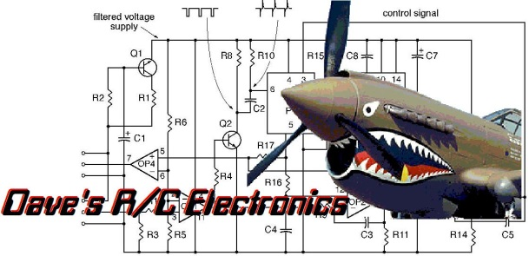
www.davesrce.com
sales@davesrce.com
(423) 544-1657
SCAN HERE

