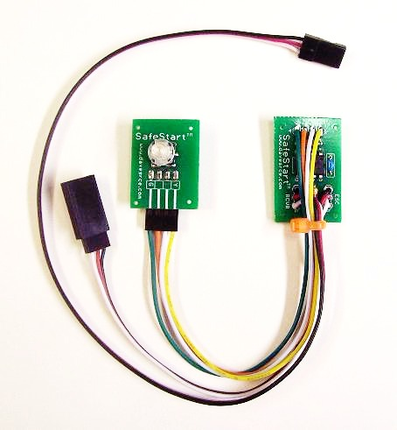
SafeStart Installation Instructions
This article is intended only as a guide to suggest one way in which the SafeStart system can be installed. As there are many different styles, sizes, and configurations of model aircraft, the modeler will have to decide for himself exactly how best to install the unit in his/her model. The location and/or method of mounting the various parts is not critical to proper operation, so feel free to locate and mount them in whatever way is best for your model.
The SafeStart system consists of two main pieces, the Mode Switch, and the Main Circuit Board, which are connected together via a 4-wire cable and connector. (Photo 1, below) The connector is attached to a 4-pin jumper on the Mode Switch (Photos 2 & 3, below), and is secured with a bead of hot glue to prevent it from vibrating loose in flight. If necessary, it is possible to cut the glue and remove the connector to facilitate installation, but if you do, make sure you re-glue the connector before your first flight. Both circuit boards are intended to be located somewhere inside the model, with the cap of the Mode Switch protruding from the model for easy access. The pictures that follow will illustrate the idea, but feel free to use whatever method works best for you and your particular installation.

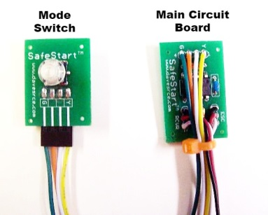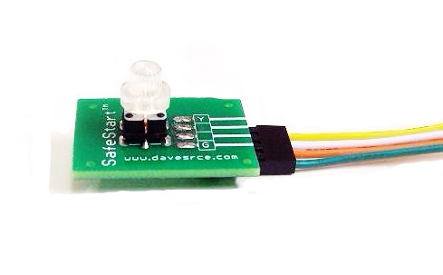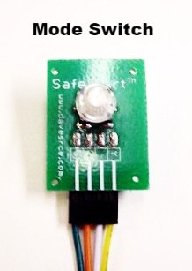

The first step is to decide on the best location for the Mode Switch. It should be mounted in a location that is easy to reach once the model is assembled and ready to fly, and easily visible so that the current mode is easy to determine. In this installation, I had several options, but I chose to mount it in a small, flat area on the lower part of the fuselage, just behind the edge of the cowling (Photo 2, next page).

Page 1
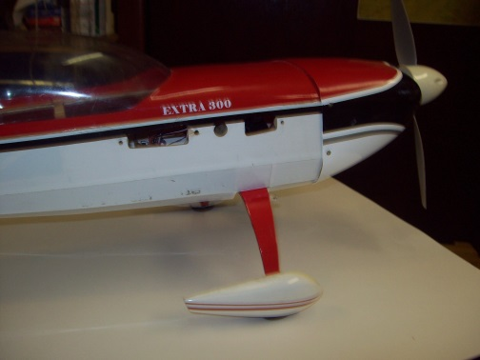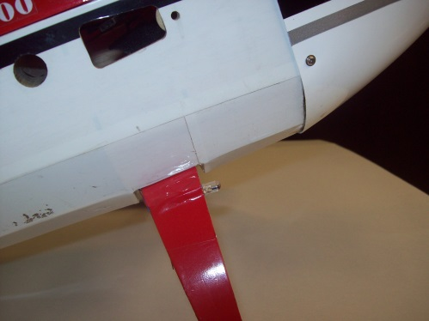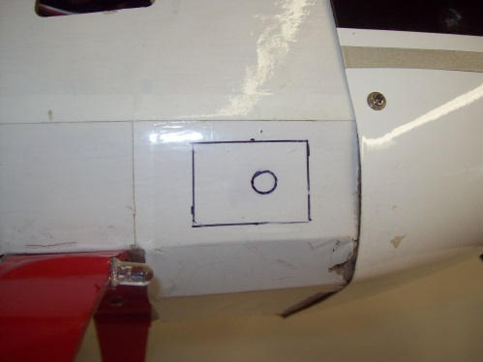

Once you decide where you want to mount the Mode Switch, draw an outline of it to make sure you have sufficient clearance both outside and inside for the circuit board, and then drill a hole to allow the cap on top of the switch to protrude to the outside of the model. (An alternate method some modelers have used it to locate the switch so that it is just below the surface of the covering. This method does not require a hole to be cut through the covering, but does require a color covering, i.e. transparent, white, or any light color, that will allow the color of the switch to shine through enough to be clearly seen from the outside.) I used a drill bit to start the hole, and a step bit to make a nice clean hole in the balsa fuselage (Photo 1, below). A soldering iron passed around the edge of the hole will clean up any balsa splinters and stick the covering down around the hole (Photo 2, below).

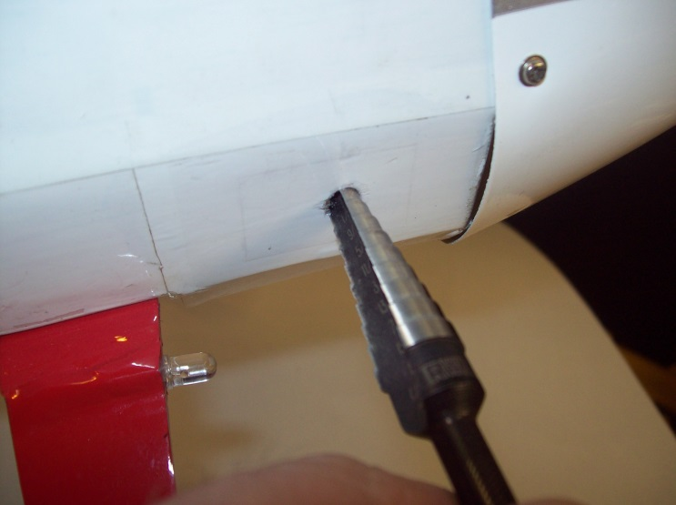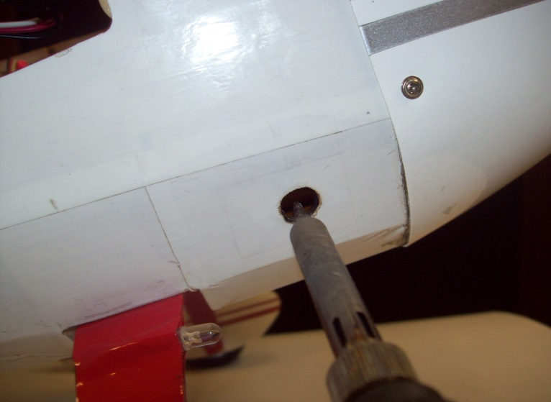

It may be necessary to add some small pieces of wood on the inside of the model to keep the switch from sticking out too far. In this installation, I added two small pieces of balsa, glued directly to the inside of the fuselage. This will make the switch stick out just enough to be easy to press, and keeps the installation looking neat and tidy.

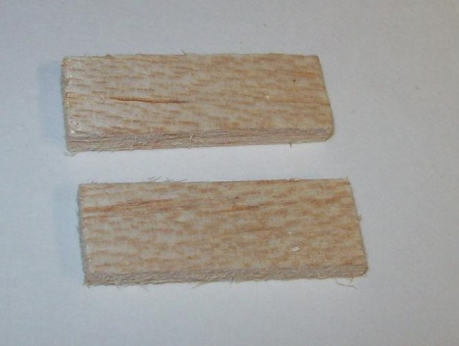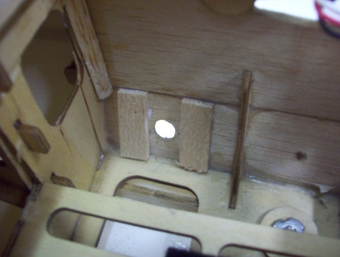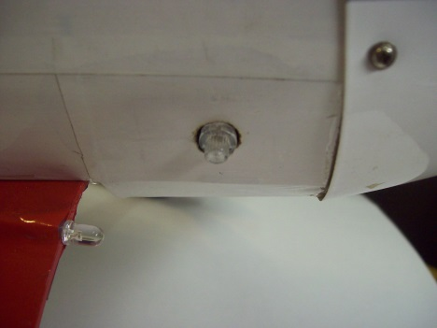

Page 2
Next I mounted the Mode Switch to the fuselage using hot glue. I ran a small bead across both ends of the green circuit board (Photo 1, below), and positioned the board on the two wood pieces, centering it in the hole in the fuselage as shown. (Photo 2, below)

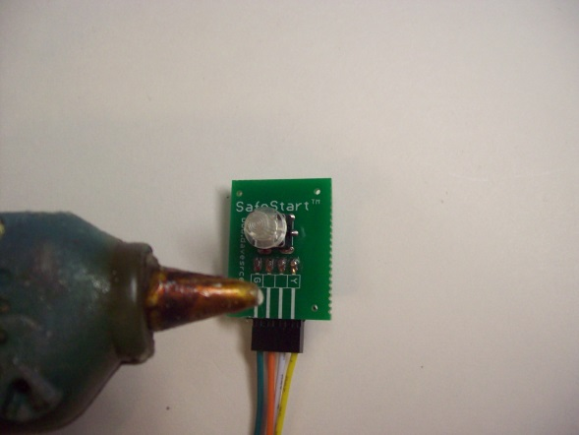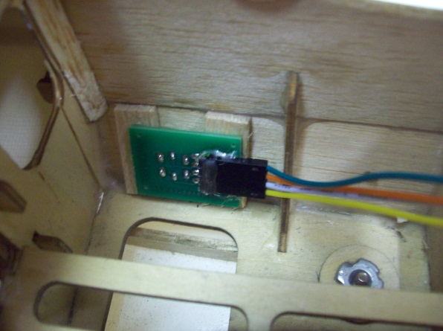

The Main Circuit Board can now be located anywhere inside the model that’s convenient, I chose to locate it right above the Mode Switch (Photo 1, below). It can be secured with foam tape, Velcro, a plastic tie wrap, or, as I did in this case, more hot glue (Photo 2, below). Location and mounting are not critical, you can use any method that works in your installation.

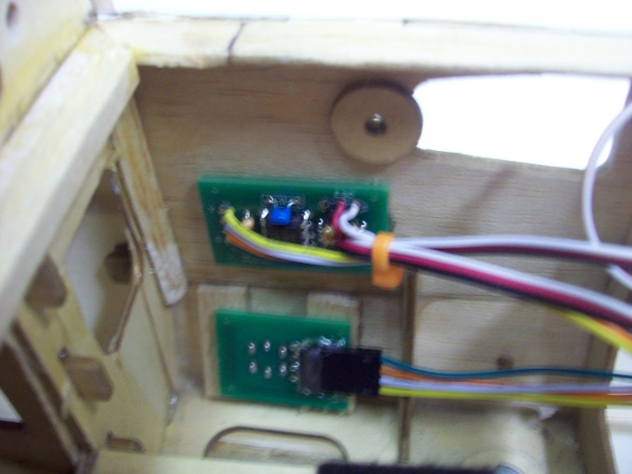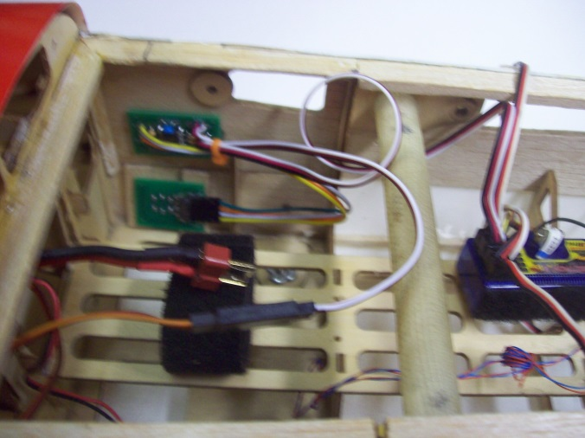

Connecting your SafeStart is the easiest part of the whole installation, just plug your model’s ESC into the male servo plug coming from the Main Circuit Board labeled “ESC”, and connect the female servo plug, labeled “To Receiver”, into your receiver’s throttle channel.

To use your SafeStart, connect your model’s flight battery as normal. If your SafeStart does not detect a valid R/C signal, the Mode Switch will remain dark (Photo 1, next page), but the circuit will prevent any unwanted or unexpected movement of the motor/prop. If the throttle stick is above the idle, or “STOP” position, the Mode Switch will blink Orange rapidly. Once the throttle stick is at the STOP position, the Mode Switch will turn solid Red. In this mode, the throttle stick is deactivated, and will not respond to any movements, while all other control surfaces will be active, allowing you to test or trim the model as needed. Once you’re ready to fly, make sure that your throttle stick in at the full STOP position, and press and hold the Mode Switch for 3 seconds. (Photo 2, next page) NOTE: If the throttle stick is not at full STOP, the Mode Switch will continue to blink Red, and will not enter the Run mode. Once the Mode Switch has been held for 3 seconds, it will begin to blink Green, and once released, it will turn solid Green, indicating that the throttle stick is now active, and the model is ready to fly. (Photo 3, next page)

Page 3

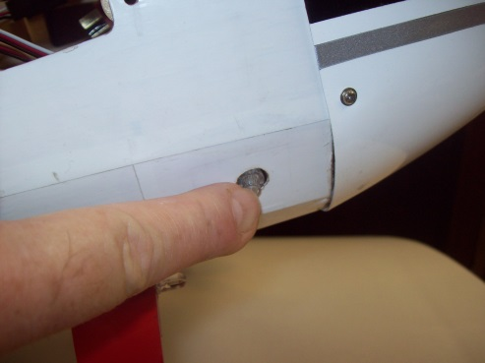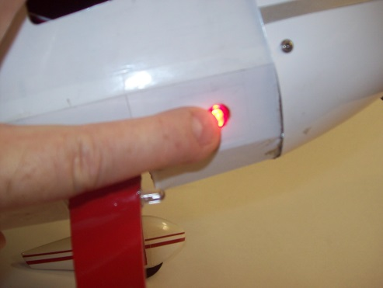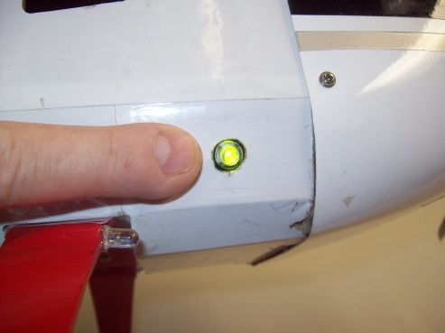

IMPORTANT: Once you have completed a flight, or at any time if you decide to abort a flight, remember to press the Mode Switch again to place your SafeStart back in the Safe mode. This will cause the unit to lock the ESC into the STOP condition, and will prevent any further movement of the motor/prop, even if the transmitter is accidentally turned off before the battery is removed from the model. Once in the final Safe Mode, the battery must be disconnected and re-connected before control is returned to the throttle stick.

LED Color and State | Mode
No LED On | Transmitter not “On”, no signal detected
LED Blinking Orange rapidly | Throttle Stick Position (TSP) is not at “Low” (Startup Only)
LED Solid Red | Safe Mode. Throttle stick is NOT active.
LED Blinking Red | Pre-Run Mode. If TSP is “Low”, and switch is held for 3 seconds, unit will enter Ready Mode
LED Blinking Green | Ready Mode. When switch is released, unit will enter Run Mode.
LED Solid Green | Run Mode. Throttle Stick is now active.

Please remember to keep hands, fingers, and body parts clear of your model’s prop in all circumstances, even after installing SafeStart. The best way to prevent an injury caused by a prop strike is to never allow your hands or fingers to be in a position to be hurt. Also, after every flight, or at any time if you decide to abort a flight, and before you carry your model to the pit area, please form the habit of placing your SafeStart into the Safe Mode by pressing the Mode button one last time. The time immediately following a successful flight is the period when many, if not most, accidents seem to occur, as you work to remove a hatch, cowling, or battery cover, and disconnect the flight battery. Placing your SafeStart into the Safe Mode after every flight will ensure that no accidental bump to the throttle stick, or loss of signal, can cause the motor to jerk and cause a possible injury to you or someone nearby. I hope your new SafeStart provides you with many hours of safer, more enjoyable flying!

If you have any questions or problems, don’t hesitate to contact me. ENJOY!

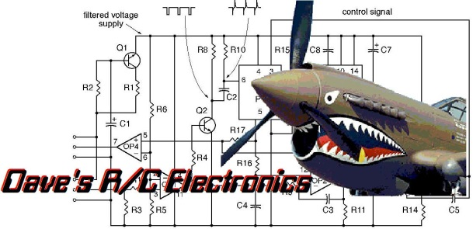
www.davesrce.com
sales@davesrce.com
(423) 544-1657
SCAN HERE

