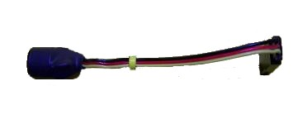
Lost Model Alarm

The Lost Model Alarm can be plugged into any channel, either by itself or with another device, using a servo wye. For best results, I suggest you attach it securely to the receiver, with tape or plastic wire ties, so that in the event of a crash it will remain connected and powered. It is equally important that the receiver battery remain connected as well, so it’s also a good idea to secure the battery and switch leads so that they can survive the impact of a crash without coming unplugged. Heat shrink tubing, wire ties, or strapping tape all work well for this purpose. If you are using standard PPM receiver, the channel used for the Lost Model Alarm should be set to 100% in both directions (-100% and +100%). If you are using a 2.4GHz receiver with failsafe, like a Spektrum receiver, there are a couple of methods you can use to active the alarm correctly. The easiest is to simply connect the LMA to the throttle channel using a servo wye. Many failsafe-equipped receivers do not output a signal to the throttle channel when no transmitter signal is present. If your receiver does, you can still use the throttle channel with a wye, by setting the low side of the throttle channel to 120-150%. Bind the receiver to the transmitter, then return the low side of the throttle channel to 100%. DO NOT RE-BIND. In the event that you lose your model, simply turn the transmitter off, and the failsafe feature will begin to output a lower signal to the alarm than is normal (i.e. greater than 100%), and the Lost Model Alarm will begin to sound off.
When the plane is first turned on, the LMA will emit three quick beeps before it begins the power-up delay. After a 15-second delay, during which the glitch counter is disabled, the unit is fully functional. In the event your model is lost in an area where it is difficult to find, take your transmitter with you, and when you get close to the crash area, simply turn the Tx off. The alarm will begin to warble loudly, directing you to the model’s location. Turning the Tx back on will silence the alarm, conserving battery power as you move in closer. Turn the Tx back off to make the alarm warble again. If you can’t find the model quickly, after one hour the unit will switch to a power-saving mode, in which the unit will alarm roughly 1/3 as often, to conserve battery power. If you can’t locate the model before dark and have to come back the next day, as soon as you get close to the crash area cycle your Tx on and off again and the LMA will resume its normal alarm mode and frequency.
As a glitch counter, the LMA monitors the signal between the Tx and Rx, and will beep once for each time it loses the signal from the transmitter during each flight. To test this function, turn the Tx on, then the Rx, and wait about 15 seconds until the power-up delay has ended. The glitch counter function of your alarm is now working. Turn the Tx off for a second or two, and then back on. After a few seconds the unit will reset and will begin a repeating sequence of one long tone to indicate a single loss of signal. Turn the Tx off and back on again, and the sequence will increase to 2 long tones. Every time you turn the Tx off and back on the number of long tones will increase by one. To reset the unit, simply turn the receiver (plane) off and back on. In normal use, the LMA will monitor the signal between the Tx and Rx and will beep to indicate the number of times a signal loss has been lost, or the failsafe mode has initiated, since the unit was last powered on.

If you have any questions or problems, don’t hesitate to contact me. ENJOY!
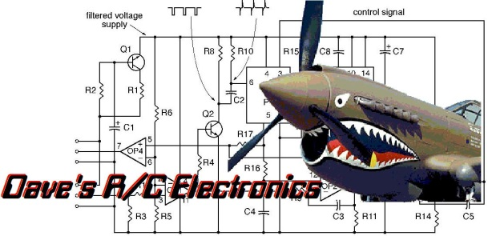
www.davesrce.com
sales@davesrce.com
(423) 544-1657
SCAN HERE

