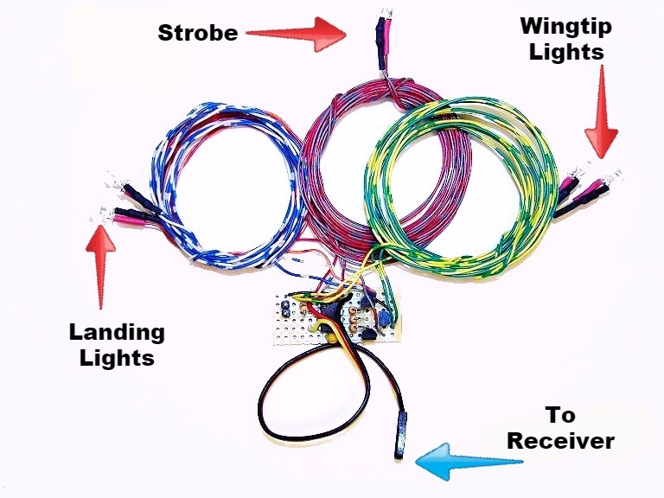
Deluxe Navigation Lights w/Strobe

The Deluxe Navigation Lights set includes 2 wingtip lights (1-red, 1-green), 2 landing lights (white), and 1 strobe light (white or red), all of which can be switched on/off from the transmitter. The strobe can be set to 2 different blink patterns, a steady, single-blink or a quick double-blink. The lights are high-brightness LEDs that will last for thousands of hours of continuous operation, and total current draw with all 5 LEDs illuminated is less than 150 milliamps. The circuit can be plugged into any channel on your receiver, either by itself or with a servo "wye". but will work best if plugged into a fully proportional channel such as channel 6 or above. To switch the lights on/off as intended, you’ll need a transmitter with a knob or a three-position switch to control the channel into which the lights are plugged. Alternately, they can also be plugged into the throttle channel and controlled by the throttle stick. (To use a switch on the transmitter, you may need to program mix or assign a switch to control the channel you select. Consult your transmitter’s manual for instructions on programming mixes.)
The circuit has three modes, 1. All lights off, 2. Wingtip lights and strobe on, and 3. All lights on. The circuit has default settings which should work well for most users, but it can easily be re-programmed to suit your needs. The default settings are as follows: turning the knob on your transmitter fully counter-clockwise (CCW) will switch to mode 1, turning it to near the center position will switch to mode 2, and fully clockwise (CW) will switch to mode 3. If the channel’s servo direction has been reversed, the action of the knob will be opposite from the previous description. The default setting for the strobe is double-blink. To change the default settings, follow the steps below.
Step 1. Plug the lights into your receiver into the channel of your choice. Make certain that the knob that controls this channel is at one extreme or the other, either fully clockwise (CW) or fully counter-clockwise (CCW), not centered. If you chose to use the throttle channel, make sure the throttle stick is either all the way up or all the way down.
Step 2. Make sure the transmitter and receiver are both off. On the left side of the board you will notice a small, brass two-pin jumper. See picture above. Short the programming jumper with a piece of bare wire or alligator clip.
Step 3. Turn on the transmitter, then the receiver. Turn the knob either CW or CCW, depending on the position at which you started, to the position you want for mode 2, wingtip lights and strobe on, and remove the jumper. Leave it off for two seconds and replace it. The wingtip LEDs will blink once.

(continued on back)

Step 4. Continue to move the knob (in the same direction, CW or CCW) to the position you want for mode 3, all lights on. Remove the jumper again, leave it off for two seconds, and replace it. The wingtip LEDs will again blink once.
Step 5. Now select the strobe’s blink rate. For single blink, turn the knob back to the first position you chose for mode 2. (Step 3) For double blink, leave it where it is. Remove the jumper one more time and leave it off. The wingtip lights will blink several times to confirm the settings, and your lights are now ready to use. Keep the strobe’s wires as far away from the receiver's antenna wire as possible, at least an inch or two, to reduce the possibility of interference.

The default settings pre-programmed into the circuit are usually perfect for most configurations. If you need help with changing them to work best with your model, feel free to give me a call, I’ll be happy to help you modify them to your model’s exact requirements.

If you have any questions or problems, don’t hesitate to contact me. ENJOY!
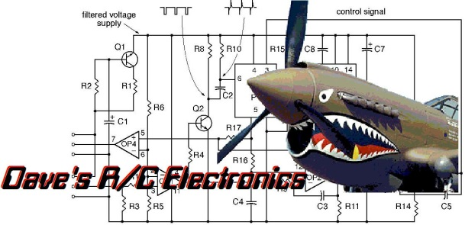
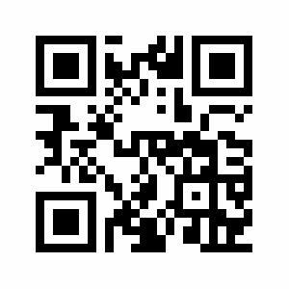
www.davesrce.com
sales@davesrce.com
(423) 544-1657
SCAN HERE

