Servo Reversing Wye with Trim Pot
The Servo Reversing Wye with Trim Pot is designed to make the installation and setup of dual servos typically used on flaps and large elevators surfaces quicker and easier. It will allow you to install a pair of servos that rotate in opposite directions in a single receiver channel, eliminating the need to use two channels, and eliminating the need for the sometimes difficult mixing required to make them operate correctly. Installation is simple and straightforward, and this device will work with any brand or type of servo, including standard analog and digital servos, and works with any receiver brand or type, including 2.4Ghz radio systems. Since the circuit affects only the signal coming from your receiver, and does not interrupt the servo’s motor wires, it will not reduce or limit the current going to your servos, and will not affect their performance in any way.
To install the Reversing Wye, simply plug the servo cable with the female end into the receiver channel you wish to use. The two remaining servo cables (with male ends) are for connection to your servos. One is marked “Normal”, and simply passes the signal received from your receiver directly to the servo. The other lead, marked “Reversed”, passes the same signal but reversed 180 degrees from the other. One servo will now move clockwise (CW), while the other moves counter-clockwise (CCW). If necessary, you can still use your transmitter to reverse the channel, but note that this will reverse the operation of both servos.
The small trim pot exposed at the top of the circuit board is used to fine tune the center position of the reversed servo. Connect the Servo Reverser to your receiver, and turn your transmitter “On”. Place the servo arms on both servos in as close to the center position as possible, and use the sub trims on your transmitter to move the servo connected to the lead marked “Normal” to the desired center position. Once you are satisfied with its position, adjust the trim pot to move the arm on the reversed servo to match the other servo arm exactly. This will ensure that both servos move the same amount when commanded by the transmitter, eliminating roll that might be induced if both servos do not move in sync with each other. Note: Both servos must be connected for the reverser to operate properly.

If you have any questions or problems, don’t hesitate to contact me. ENJOY!
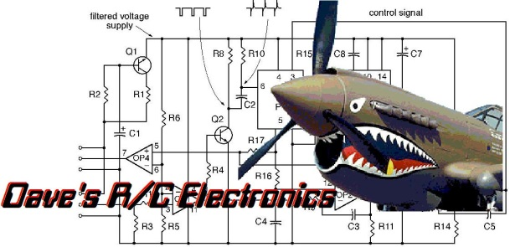
www.davesrce.com
sales@davesrce.com
(423) 544-1657
SCAN HERE

