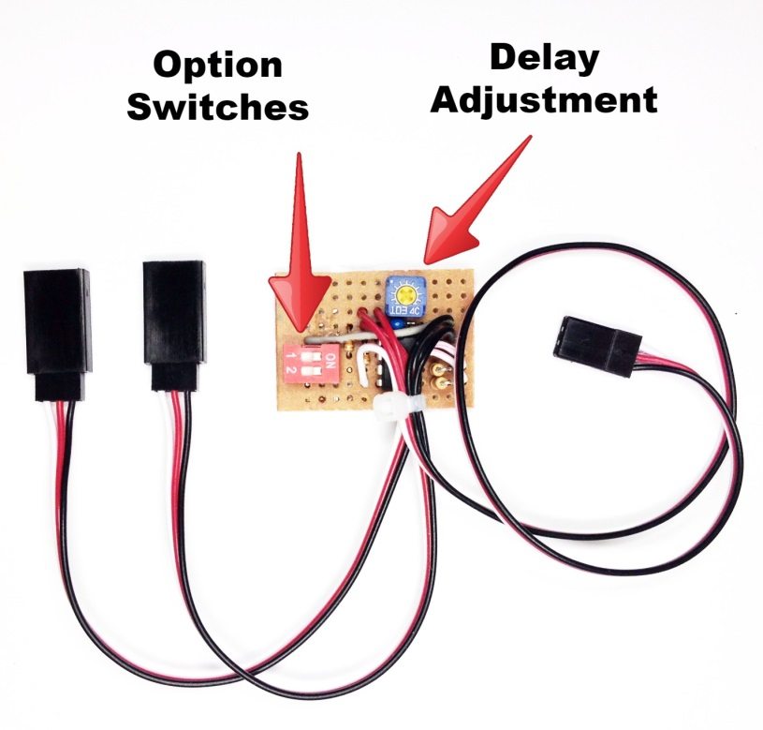
Electric Retract and Gear Door Sequencer

The Electric Retract and Gear Door Sequencer is designed to provide coordinated control of the retract controller and gear door servos used on a plane equipped with both brushed motor retracts and gear doors, and utilizes a microprocessor to control both. It provides the option of leaving the gear door(s) open after the gear have been lowered (P-47 style), or having the gear door(s) close after the gear are down (P-51 style), and features an adjustable delay that allows the modeler to time the opening/closing of the model’s gear doors to accommodate the speed of the model’s retracts. Multiple gear door servos may be controlled at the same time with the use of a standard servo Y.

The controller can be located inside the model in any convenient location. The female servo lead from the controller will normally be connected to the receiver’s gear channel, although it can be connected to any spare channel and activated via a program mix. The two male servo leads are connected to the air valve servo and the gear door servo(s) respectively, all are clearly marked. A small potentiometer near the top of the circuit board provides adjustment for the delay function, which can range from 0 seconds (no delay) to approximately 8 seconds. (Sequencers with a longer delay are available, just give us a call). Turning the screw clockwise (CW) decreases the delay, turning it counter-clockwise (CCW) increases the delay. The red Option Switches on the left side of the board control the other functions of the sequencer. Switch #1 controls whether or not the gear doors close after the gear have been lowered. If “OFF”, the doors will remain open after the gear have been lowered, if “ON”, they will close. (Gear doors will always close after the gear have been raised.) Switch #2 reverses the direction (rotation) of the gear door servo(s), to facilitate easier setup with different model configurations. To prevent damage to your gear doors, new programming prevents either servo from moving when the receiver is first powered. Once the gear switch has been moved from its initial position to the opposite position, the air valve servo will move to the indicated position, and the gear doors will cycle in accordance to the way they are set up using the instructions that follow. Follow them carefully to prevent damage to your gear doors during the initial setup.

(Continued on back)

Leave the linkage to your gear door servo(s) disconnected until you have completed steps 1 through 7 completely!

1. If you want the gear doors to close after the gear have been lowered, turn the screw on the small pot located at the top edge of the circuit board fully counter-clockwise (CCW). This will provide maximum delay for the setup procedure. If your gear doors are to remain open after the gear are lowered, you can skip this step.
2. Make sure both Option Switches are “OFF”. This will prevent the gear doors from closing until you have established the correct direction of rotation for your gear door servo(s), and have made sure that the gear switch on your transmitter is operating in the direction you prefer.
3. Connect the cables from your air valve and gear door servo(s) to the proper male servo leads as marked. Connect the cable marked “To Receiver” to your receiver’s gear channel, or to the channel of your choice. Move the switch on your transmitter to the position you prefer for “Gear Down”.
4. Power your receiver on. The servos will not move until you move the gear switch to the opposite position. Toggle it back and forth one time, and then move it to the position you prefer for “Gear Down”. Note the action of the retracts, and if the gear move to the “Gear Up” position, reverse the direction of the channel in your transmitter. Consult your transmitter’s manual for instructions on reversing a channel. Once your gear move up and down when the switch on your transmitter is in the correct up/down positions, proceed to step 5.
5. Note the direction that the gear door servo is rotating, either clockwise or counter-clockwise (CW or CCW). If it is rotating in the wrong direction, move Option Switch #2 to the “ON” position. Cycle the gear up and down several times to verify that the gear door servo is moving in the right direction to open the gear doors when the gear are down, and close them when the gear are up.
7. If you want the gear doors to remain open after the gear are down, make sure Option Switch #1 is in the “OFF” position, and skip to Step 8. If you want the gear doors to close after the gear have moved “Down” (P-51 style), move Option Switch #1 to the “ON” position. Cycle the gear to the “Gear Down” position, and note the delay between the time the gear are fully down and locked and the closing of the gear doors. (Be patient, the initial delay will be about 8 seconds.) If the delay is too long, turn the screw on the pot clockwise (CW) in small increments and cycle the gear again. Repeat until you find the setting that provides the correct timing for your retracts.
8. Now connect the linkages to the gear door(s) and make any necessary final adjustments.

Following the steps above should ensure that your sequencer works smoothly and reliably.

If you have any questions or problems, don’t hesitate to contact me. ENJOY!
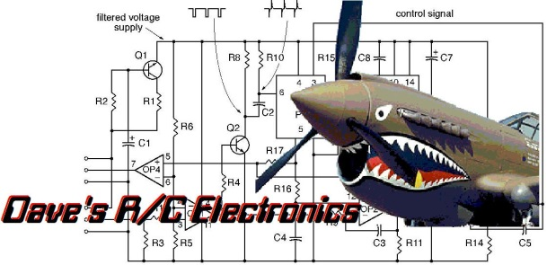
www.davesrce.com
sales@davesrce.com
(423) 544-1657
SCAN HERE

