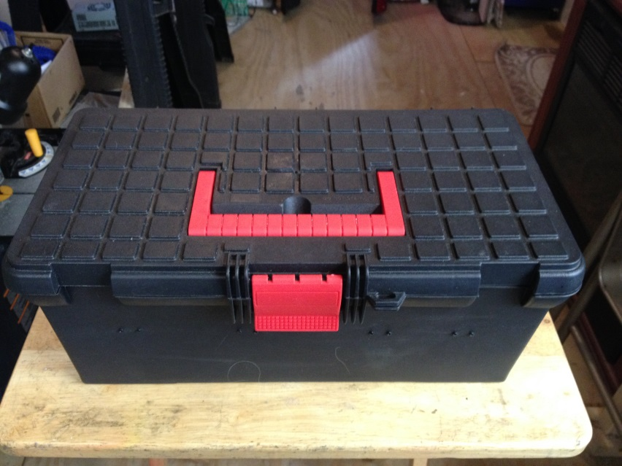
12/24 volt Power Supply
This unit consists of two 41 amp Dell Server Power supplies that are mounted together in a compact tool box, and are wired together (in series) to provide either 12 or 24 volts of highly-regulated DC current for use in powering battery chargers or other devices that require a DC power source. The power supplies used are recycled from computer servers, and have been tested and refurbished, if necessary, for reliable service. The outputs have been routed to the top panel to a set of 4.0mm banana jacks that can provide either 12 or 24 volts DC, and the 24 volt output is monitored via a digital volt meter also mounted on the top panel. A fan is installed to provide extra cooling in case of heavy charge current levels, and LED strip lights that face downwards are provide to make it possible to use the power supply even in the dark, without spoiling your night vision!
Operation is simple and straightforward. Plug the AC power cord (included) into a suitable 110 volt AC receptacle, and into the female AC socket on the back of the unit. The switch on the far right side of the top panel powers the unit on/off. Upon power up, the fans should come on, and the volt meter should indicate the output of ~ 24 volts DC. The green pushbutton switch controls the LED strip lights. The 4.0mm banana jacks on the far left provide DC voltage, they can be used to connect two 12 volt chargers, or one 24 volt charger. Polarity and voltage outputs are marked. Should either power supply detect a problem, like a short circuit, a current overload, or a high internal temperature, that unit will shut down to prevent further damage. Remove the short, allow the unit to cool, or reduce the charge rate, and turn the unit off for a few seconds. Turn it back on, and the unit should re-set itself and resume operation.

If you have any questions or problems, don’t hesitate to contact me. ENJOY!
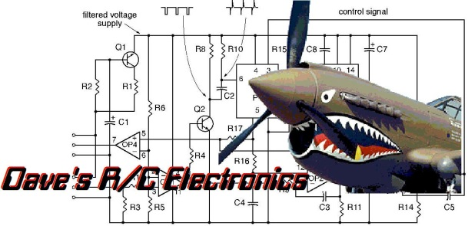
www.davesrce.com
sales@davesrce.com
(423) 544-1657
SCAN HERE

