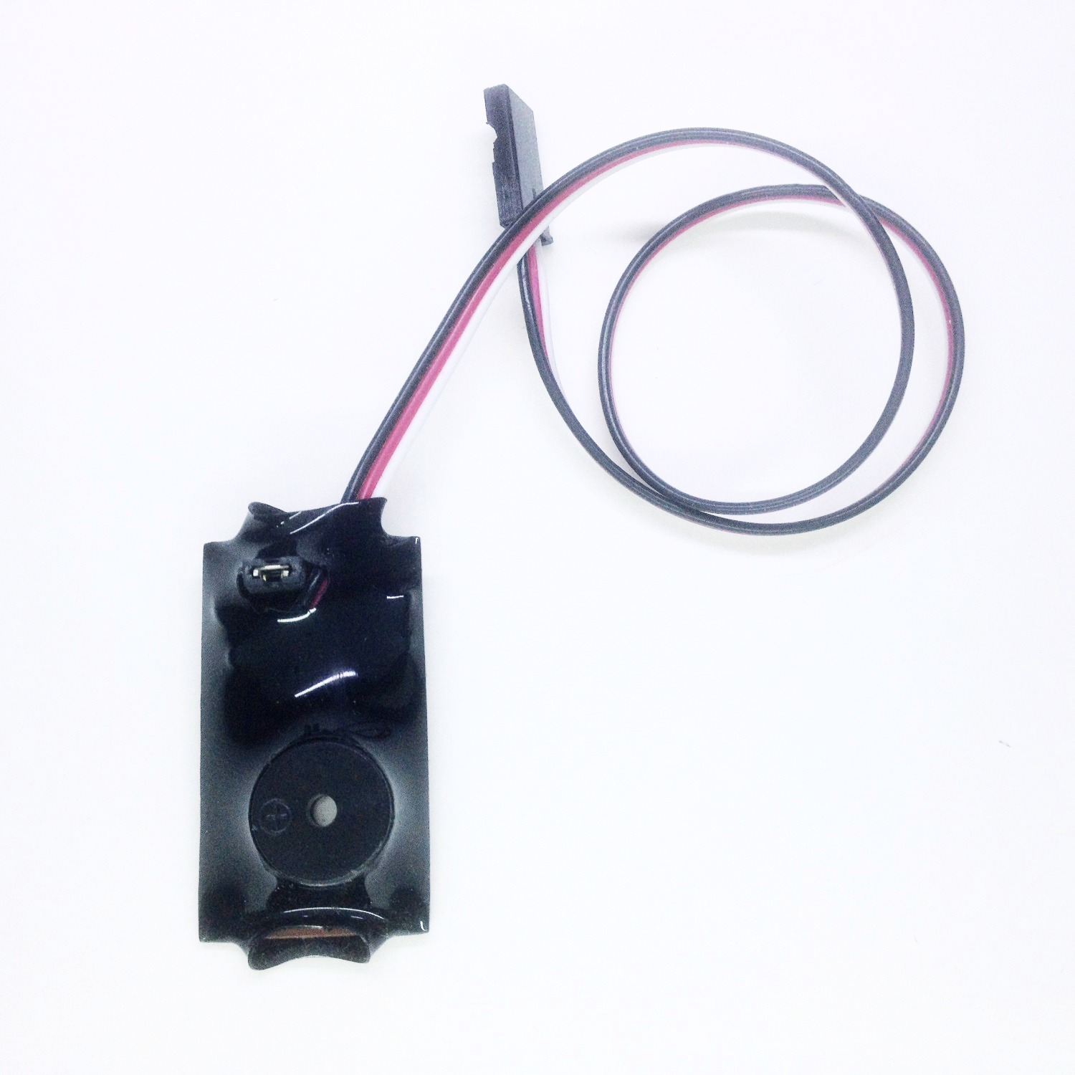
Battery Minder

Battery Minder is a small monitoring device designed to alert you to a plane that has been left “on”, with the receiver battery still connected, after the transmitter has been turned “off”. With the introduction of receivers that feature Fail Safe technology, it has become not only possible, but actually very easy, to damage an expensive receiver battery by leaving it connected inside a model after flying. Since the Fail Safe settings continue to send a valid signal to the servos even after the link to the transmitter has been broken, if the problem isn’t realized, the drain on the receiver battery continues until the battery has been discharged so low that a cell (or cells) are damaged and the battery is ruined. Battery Minder will alert you to the problem and keep you from having to replace that expensive Li-Po, Li-Ion, or A123 battery pack. Small, lightweight, and easy to use, it’s a great addition to any model, no matter what kind or type of battery pack you are using. Works with any type or brand of receiver, from 72MHz to 2.4GHz, and is completely passive, it will not affect the performance of any other part of your radio system.
How to connect it: Battery Minder is connected to any channel in your receiver, either directly or using a standard servo “Y”. It will work best when connected to an “active” channel, that is, a channel like the elevator, ailerons, or rudder, one that is frequently and often used during normal flight. If connected directly, simply use a servo “Y”. You can also connect it to a spare channel that has been mixed with an active channel. Make sure the slave channel is set at 100% in both directions, with all links and trims of the master channel also active. You may also choose to use a mix to make the slave channel active with a switch on the transmitter.
How it works: Battery Minder monitors the channel to which it is connected (or slaved) for movement. If the stick, knob, or slider that controls the channel is moved, the timing circuit that controls Battery Minder is reset. This occurs once every second, and the re-setting of the timer is done each time movement is detected. If the channel reports no movement for the period of time determined by the jumper (see next paragraph), the alarm begins to “beep” the SOS signal, alerting you to the fact that the receiver is “on” but that there has been no movement of the channel. To silence the alarm, either turn the plane “off”, or move the channel.
The small 2-pin jumper on the main board is used to determine the timing of the monitoring loop. If the jumper is present, the timing loop is 3 minutes, with the jumper removed, it is 5 minutes.
Additional features: To make Battery Minder compatible with older receivers that do not feature Fail Safe, the programming is also designed to monitor the channel for any valid signal coming from the receiver. If a signal is not present, the alarm will begin to sound immediately, with no delay, to alert you to the fact that the receiver is powered but is receiving no valid signal from the transmitter. With these receivers the monitoring loop is not used.

If you have any questions or problems, don’t hesitate to contact me. ENJOY!
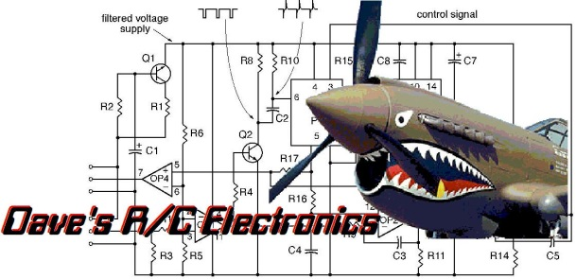
www.davesrce.com
sales@davesrce.com
(423) 544-1657
SCAN HERE

