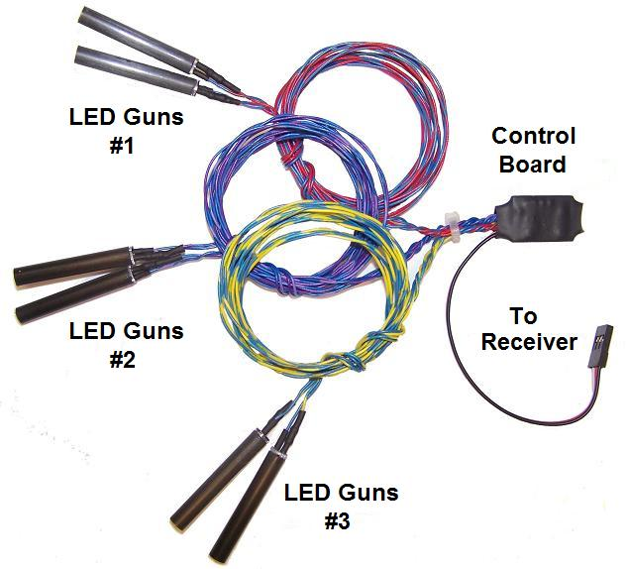
LED Cannons

This circuit is designed to simulate the guns commonly found in the wings, in the nose, and on the fuselage of many WWII fighters. The 5mm carbon fiber tubes can be installed anywhere on the model, and feature a high-brightness orange LED that flashes randomly to simulate a muzzle flash. There are 6 LED/carbon fiber tubes, which are connected to 3 separate circuits, so they can be grouped together in the leading edge of a wing and will appear to fire randomly. The 3 circuits are controlled by a micro-processor, and each circuit is wired to 2 LEDs that use wires of the same color combinations, so you can arrange the firing order of the cannon on each wing as you see fit for maximum realism. I recommend that you use a different order on each wing, for instance, 1-2-3 on one wing and 3-2-1 on the other. The carbon fiber tubes can be installed by drilling a small ¼” hole through the leading edge of the wing, or can be glued onto the fuse or cowling at any location that is correct for your model. They can all be installed at the same depth, as is scale for aircraft like the P-40 Warhawk, or at graduated depths, as is correct for many fighters like the P-47 Thunderbolt. I recommend that you allow any excess length to simply extend into the wing area, rather than cutting it off, so that the brightness (or flash) of each cannon will appear to be relatively the same. Glue the tubes in place with a drop of cement or silicone, and route the wires through the wing to the area where the circuit will be located. Connect the servo wire from the board to a spare channel on your receiver, and program that channel to the switch (or knob) of your choice. Now you can simulate cannon fire by simply toggling the correct switch. The flashing effect is enhanced by a completely random firing pattern, and also includes a random delay between “bursts“, that will simulate a pilot’s tendency to fire his cannon in short bursts of fire, rather than in a continuous stream.
The most difficult part of installing your cannon will be routing the wires from the LEDs through the wing’s leading edge and into the fuselage. Because the LEDs can’t be inserted from the back of the leading edge (unless you’re building a kit), it may be necessary to cut the wires to the LEDs, route them through the wing as required, and reconnect them once they’re installed. For 2-piece removable wings, you may want to install a multi-pin connector to allow you to disconnect the LEDs just like you do the aileron/flap servos. Check my website for a simple, 6-pin connector that's perfect for the job. The LED's wires use color combinations that are easy to distinguish, so once you’ve finished installing them it should be easy to get them matched back up correctly. Even if you accidentally get one backwards, don’t worry! The LEDs will not be damaged by reverse wiring, they just won’t work. Once the wires have been spliced back together, I recommend a drop of solder and a little heat shrink tubing on each joint. On models with a 1-piece removable wing, the entire circuit can be located inside the wing, and the servo cable routed out just like an aileron or flap servo wire. Just use a short servo extension to connect it to your receiver.

If you have any questions or problems, don’t hesitate to contact me. ENJOY!
www.davesrce.com
sales@davesrce.com
(423) 544-1657
SCAN HERE

