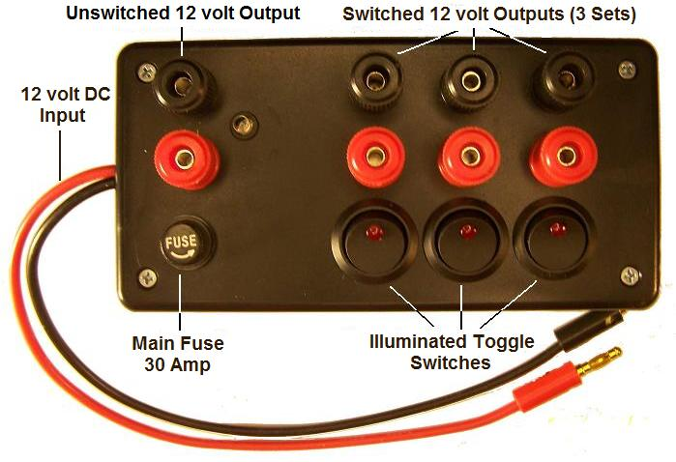
12 volt Power Distribution Box

The 12 volt Power Distribution Box is designed to provide a convenient way of connecting multiple 12 volt devices to a single 12 power source. It can be used to connect several field chargers to a 12 volt battery or power supply, and is fuse protected. It also allows the user to control the outputs using the toggle switches located on the top panel. The 12” input cable is made of flexible, 12-gauge silicone wire to accommodate high current flow, and is terminated with high-quality gold plated banana plugs to provide consistent, reliable power transfer.
Instructions for use are fairly simple and straightforward. Connect the input cable to any 12 volt power source, observing correct polarity (red/positive (+) and black/negative (-)) The green LED on the top panel will illuminate, indicating that the box is receiving a valid 12 volt input. If the LED does not come on immediately, check your connections and your power source. The 2 banana jacks on the left side of the panel are unswitched, and are available anytime the box is connected to a working power source. There are 3 additional sets of jacks along the top of the panel that are each switched via the illuminated toggle switches located under each pair of jacks. When a switch is toggled to the “On” position, the red LED in the switch will illuminate, indicating that the set of jacks immediately above it is now “On”. The entire unit is protected by a 30 amp fuse, the holder is located under the unswitched jacks on the lower-left side of the top panel. Each of the switched jacks is also protected by a separate 10 amp fuse located inside the unit. To replace any of the 10 amp fuses, remove the 4 screws holding the cover on, and lay the top panel upside down on a workbench. You’ll see the 10 amp fuses soldered between the toggle switches and the red banana jacks. Remove the blown fuse and replace with a similar fuse, available at most electronics supply stores, or contact me for a replacement.

If you have any questions or problems, don’t hesitate to contact me. ENJOY!
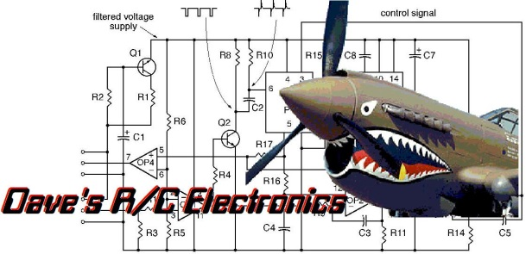
www.davesrce.com
sales@davesrce.com
(423) 544-1657
SCAN HERE

