Night Racer ARF
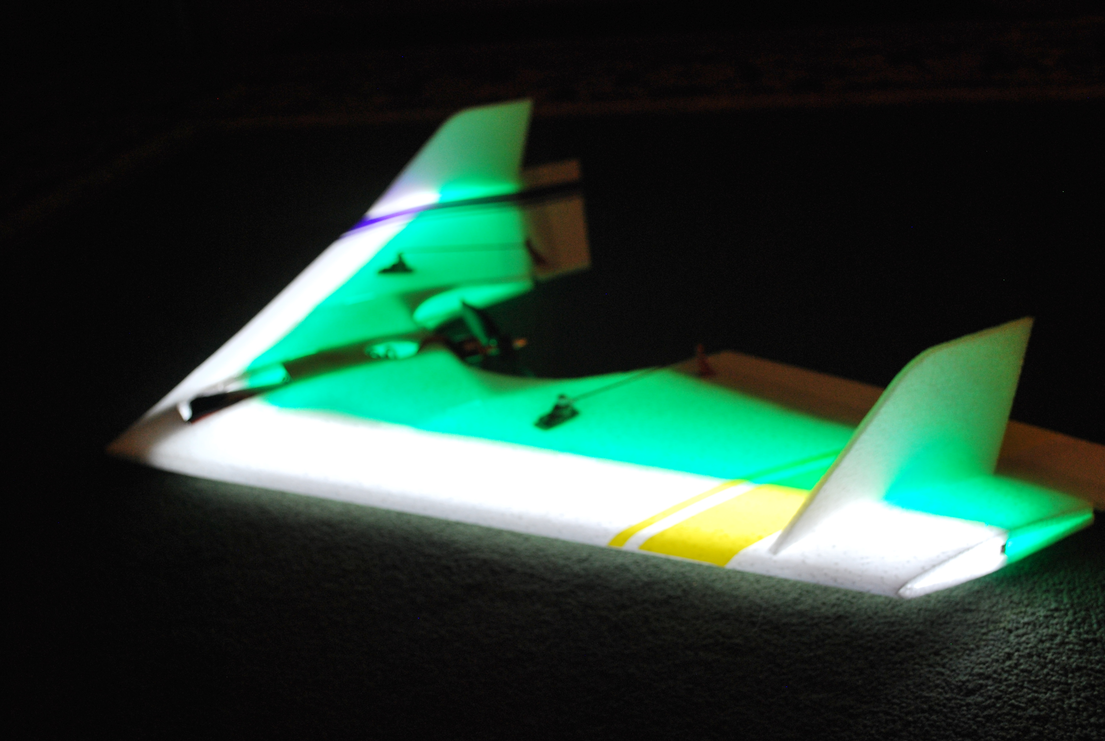

Congratulations, and thanks for your purchase of a Night Racer ARF! This manual will include information that you can use to get the most from your new plane.
This plane comes fully assembled, except for the two vertical stabilizers that mount near the ends of each wing tip. Slide each stabilizer into the slots cut into each wing, with the angled side facing forward as in the picture above. You can use foam-safe CA, Hot Glue, or even white (Elmer’s) glue to secure them in place. Now all you’ll need to do install the receiver and battery, and you’re ready to fly. Tuck your receiver all the way back into the rear of the battery compartment, as close to the motor’s firewall as possible. This plane requires a 3-cell 11.1 volt Li-Po battery, and is designed to fly best with a 1300-1500mAh size. The battery compartment is sized to allow a 1300mA pack to fit snugly, so you may have to enlarge it slightly if you choose to use a larger capacity pack. The LEDs inside the plane are powered directly from the flight battery, there is a pair of red JST connectors in the battery compartment that are used to disconnect the lights for daytime flying. Place the battery in the battery compartment and secure it with a small piece of Velcro, keeping it as far forward as possible. This will give you the correct balance for stable flying. The ESC is rated at 30 amps and is programmable, and the default settings work best for this plane. The instruction sheet for the ESC is attached to the plane.
Repairs can be made with either foam-safe CA or hot glue. Just be sure to keep the tip of the glue gun away from the foam itself, or it will melt it. Drip or drizzle the glue where you need it and press the pieces together. White glue also works well, but is slower to cure and not quite as strong. If the ends of the LED strips begin to lift or come loose, just a drop of either type of glue will hold them down firmly.
If you need replacement parts, just let me know. I keep the parts for this plane in stock (motor, ESC, servos, etc.), and you can check our website (link is below) for prices. Fly safe, and have fun!

If you have any questions or problems, don’t hesitate to contact me. ENJOY!
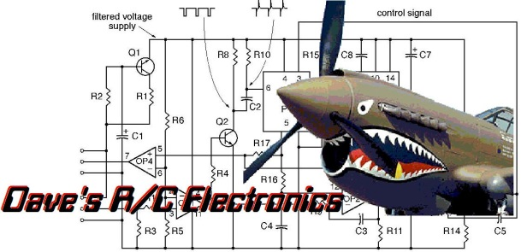
www.davesrce.com
sales@davesrce.com
(423) 544-1657
SCAN HERE

