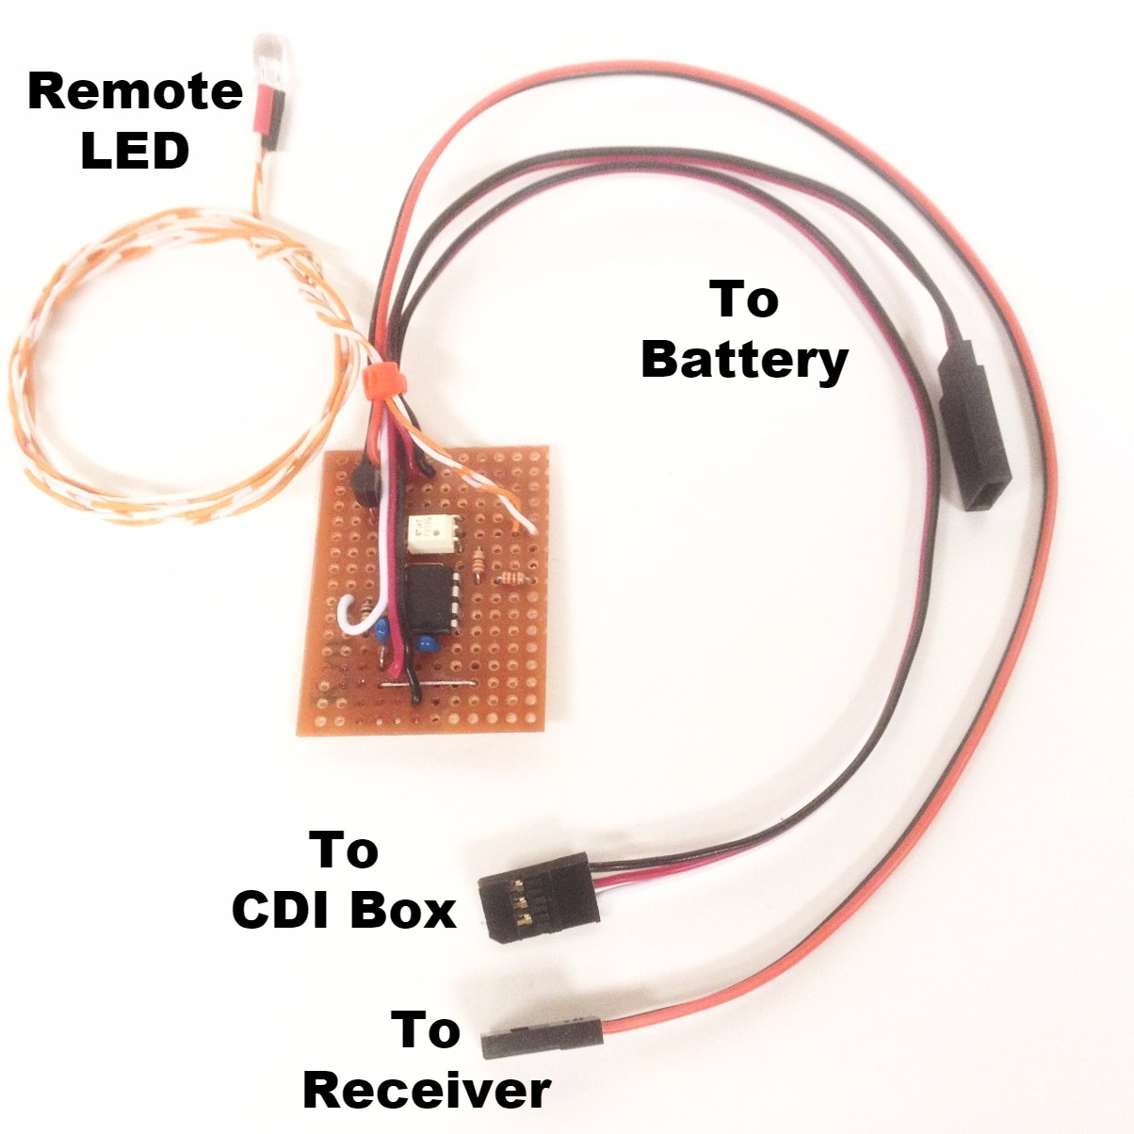
Opto-Isolated Kill Switch
Designed exclusively for gas engines that utilize a CDI (Capacitive Discharge Ignition), this device will provide a convenient and safe way to switch the ignition box on/off from the transmitter. Most importantly it is fully opto-isolated, which means that the output of the circuit is insulated electronically from the receiver, so the high-frequency pulses (spark) created by the ignition box cannot back up into the receiver and cause interference that might compromise your model. It features an on-board regulator that makes it compatible even with HV (high voltage) receivers using 2S or 3S battery packs, no regulator needed. Also included is a remote LED to indicate when the CDI is "on".
IMPORTANT NOTE: The output of the switch is NOT regulated, only the input coming from the receiver. For this reason, it is important that you use a battery that is the correct voltage and current rating to power your CDI box. Please consult the owner's manual that came with your engine or ignition box for information on the proper battery for your ignition system.
How to connect it: Plug the cable from your Opto-Isolated Kill Switch marked “To Receiver” into any spare channel in your receiver. Program a mix to select a switch on your transmitter that will activate the channel to which the Opto-Isolated Kill Switch is connected, and make sure the channel’s End Points or ATV are set to 100% in both directions. We recommend that you also set the Fail Safe settings on this channel to cut your switch “off” in the event that the receiver loses the signal from the transmitter. Consult your receiver’s owner’s manual for information on changing your Fail Safe settings.
Plug the CDI’s battery pack into the cable marked “Voltage In”, and connect the cable marked “Voltage Out” to the cable from the CDI box into which the battery is normally connected. We recommend that, for safety purposes, you also use a separate manual switch, (slide or toggle) like one of our HD Switch with LED & Charge Jack, to disconnect the CDI’s battery pack when the engine is not running. This will give you 2 layers of safety, an important consideration when dealing with a powerful gas engine.
Now mount the LED (optional) somewhere on the model so that it is visible as you start the engine. The LED should be illuminated any time the channel into which your Kill switch is plugged is active, however the LED will not be off if you are also using a slide or toggle switch to disconnect power to the ignition box separately. Turn the manual switch “on”, and your engine should be ready to fire.
IMPORTANT! Start your engine and test your switch each time before flight. We are not responsible for damage that may occur due to failure or misuse.

If you have any questions or problems, don’t hesitate to contact me. ENJOY!
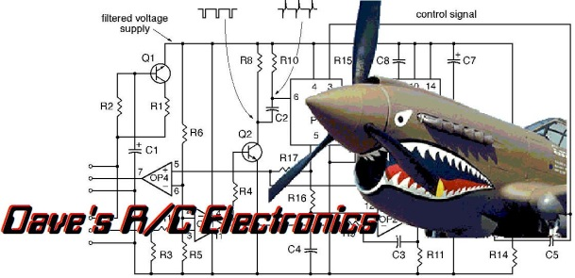

www.davesrce.com
sales@davesrce.com
(423) 544-1657
SCAN HERE

